SQL labs

AC0 Landing Zone


Contents
1. Setup 1
2. Task 1: Creating a schema 4
2.1. Scenario 4
2.2. Your task 4
2.3. Example information to store 4
2.4. Deliverable 5
3. Task 2: Querying a database 6
3.1. Find all customers 6
3.2. Find products in stock 6
3.3. Show orders from a specific customer 6
3.4. Find the top ten most expensive products 6
3.5. List all beverages 7
3.5.1. Stretch 7
3.6. Solutions 8

Setup
- Open the SSMS from the desktop.
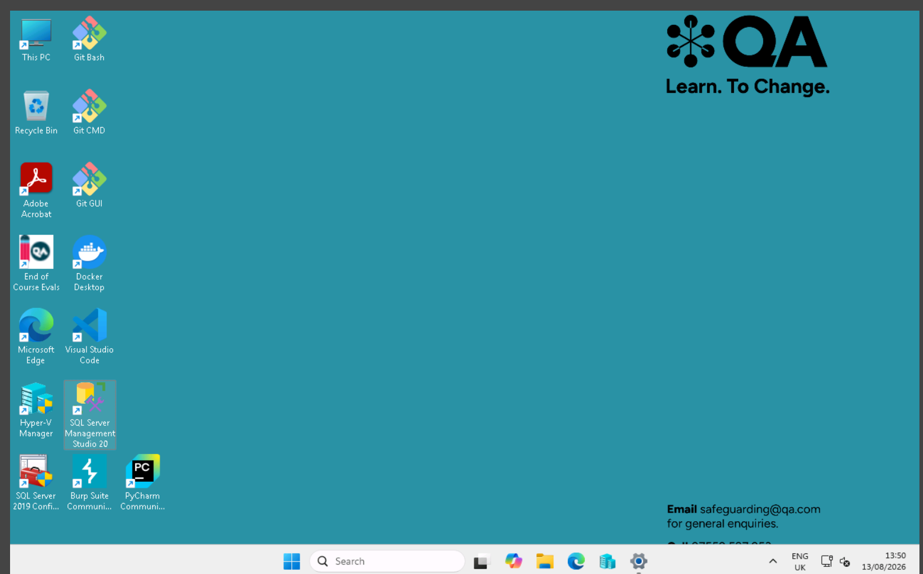

- Connect to the default database.
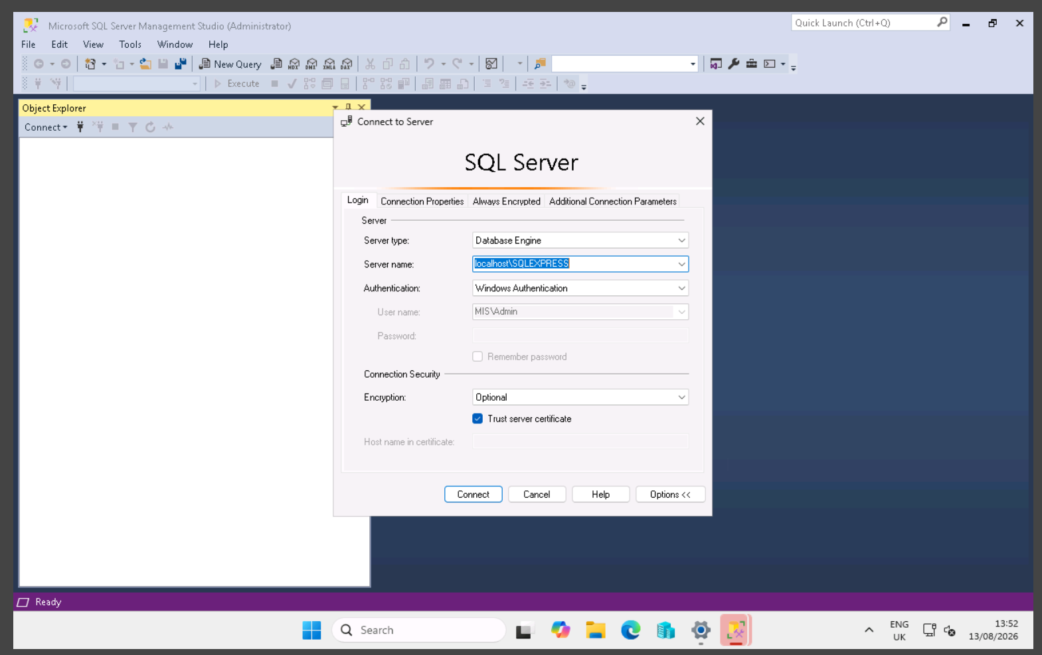
- Open a new query window with the New Query button.
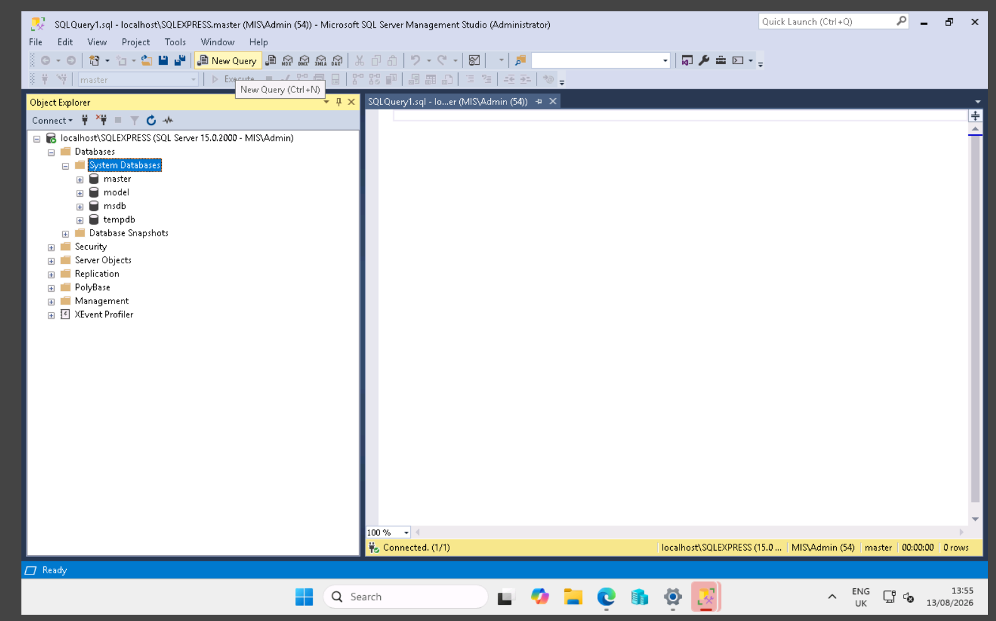

- Go to raw.githubusercontent.com/microsoft/sql-server-samples/refs/heads/master/samples/databases/northwind-pubs/instnwnd.sql and copy the entire script.
- Paste the script into the new query window.
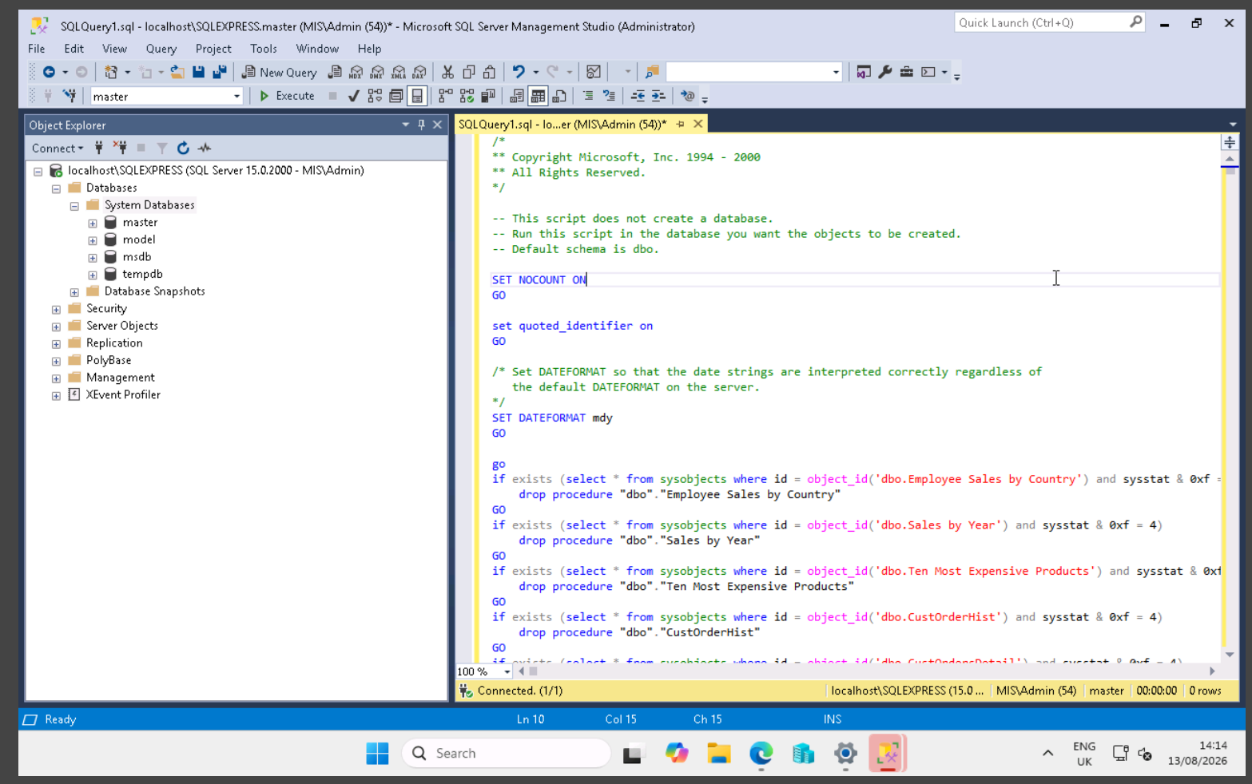
- Execute the script.
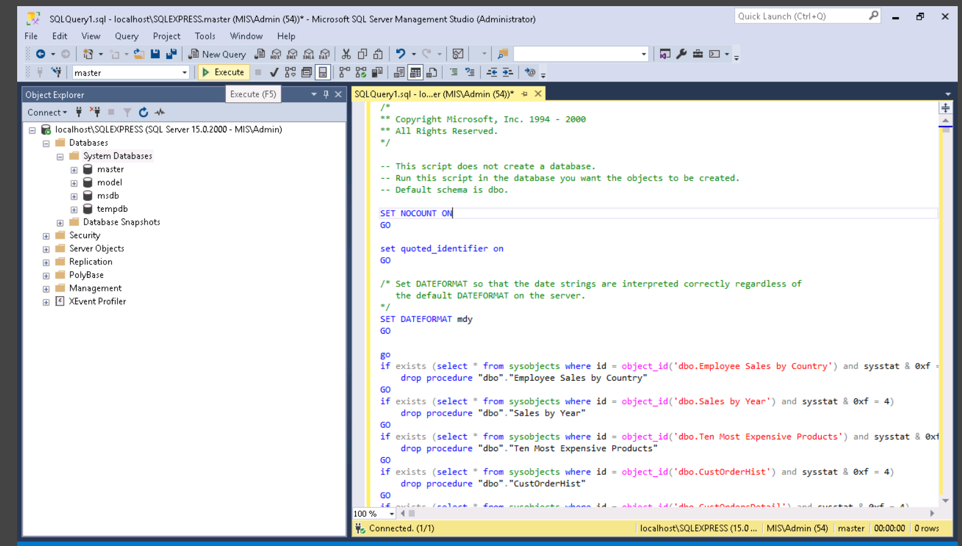

- You should now see this screen if you expand the master table.
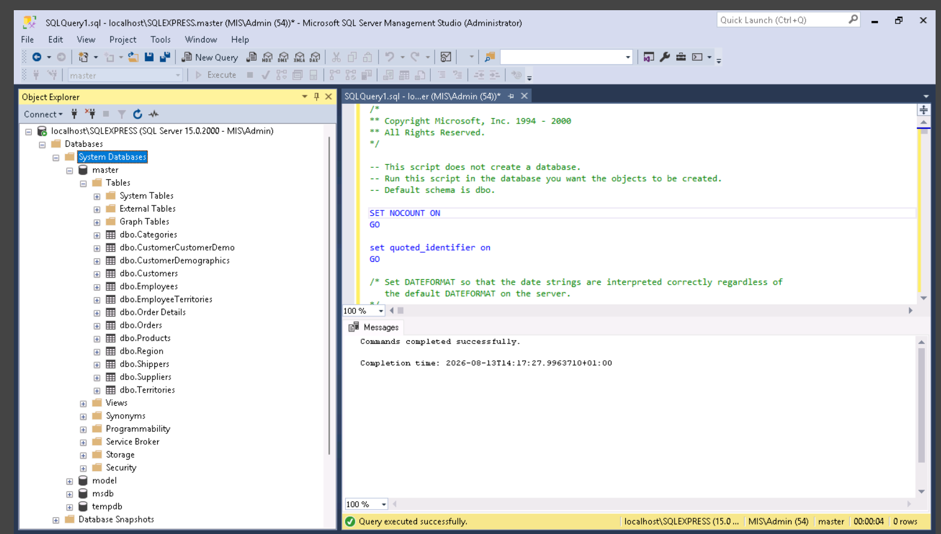

Task 1: Creating a schema

Scenario
A local training provider runs short courses for learners. Each learner can enrol on multiple courses, and each course can have multiple learners enrolled.
The training provider wants to store information about:
- Learners.
- Courses.
- Enrolments.

Your task
Design a simple relational database schema for this scenario.
Your design should include:
- A table for Learners.
- A table for Courses.
- A table for Enrolments.
- A Primary Key (PK) for each table.
- Any Foreign Keys (FK) needed to create relationships between the tables.
- A simple diagram or description showing how the tables are related.

Example information to store
Learners:
- Learner ID
- First name
- Last name
- Email address
Courses:
- Course ID
- Course name
- Duration
Enrolments:
- Enrolment ID
- Learner ID
- Course ID
- Enrolment date

Deliverable
Create a relational schema showing:
- Table names.
- Field names.
- Primary keys.
- Foreign keys.
- Relationships between tables.

Task 2: Querying a database
Write SQL queries to answer the following questions.

Find all customers
From the Customers table, display:
- Company name.
- Contact name.
- City.

Find products in stock
For all products where there is at least one item in stock, display:
- Product name.
- Unit price.
- Units in stock.

Show orders from a specific customer
For orders placed by customer ALFKI, display:
- Order ID.
- Order date.
- Freight.

Find the top ten most expensive products
Display:
- Product name.
- Unit price.
Sort from highest to lowest price.

List all beverages
Display all fields in Products, but only for beverage products.

Stretch
Find all product info for beverages with just one query.

Solutions
Find all customers
SELECT CompanyName, ContactName, City from dbo.Customers;

Find products in stock
SELECT ProductName, UnitPrice, UnitsInStock FROM dbo.Products WHERE UnitsInStock > 0;

Show orders from a specific customer
SELECT OrderId, OrderDate, Freight FROM dbo.Orders WHERE CustomerID = 'ALFKI';

Find the top ten most expensive products
SELECT TOP 10 * FROM dbo.Products ORDER BY UnitPrice DESC;

Find all beverages
SELECT CategoryID FROM dbo.Categories WHERE CategoryName = 'Beverages';
SELECT * FROM dbo.Products WHERE CategoryID = 1;

Stretch
SELECT * FROM dbo.Products WHERE CategoryID = (SELECT CategoryID FROM dbo.Categories WHERE CategoryName = 'Beverages');


